The People’s Assembly, convening on the 29th of August 2023 under the 37th PA Meeting.

The Assembly, recognising the current situation,

Constitutes the need to recognise Subterranea (see appendix A for the territory and appendix B for the location).
The head representative is to be Monquilus.

And proceeds.

Signed by,
Monquilus
Thanster
Emeralda_axe7
Lunar_Lunatic_

[Motion 37-1: To recognise Subterranea]

APPENDIX A: Territory
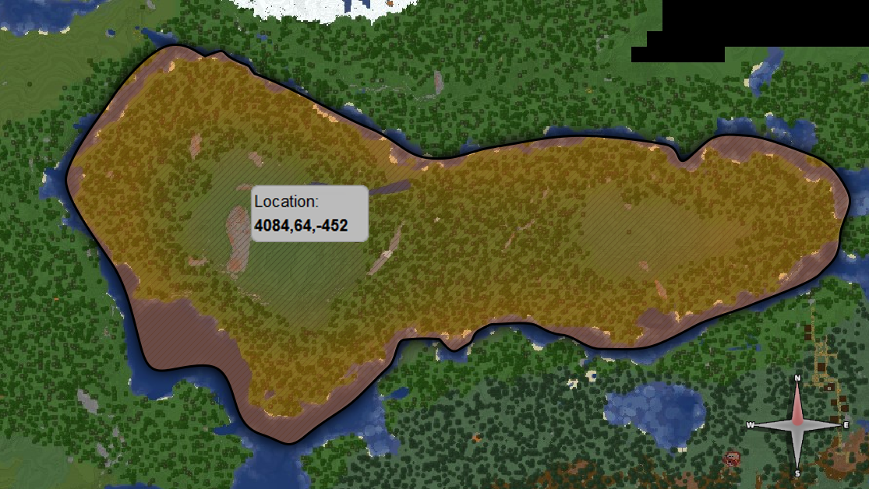

APPENDIX B: Location
